Part 1:System
1,System Module:
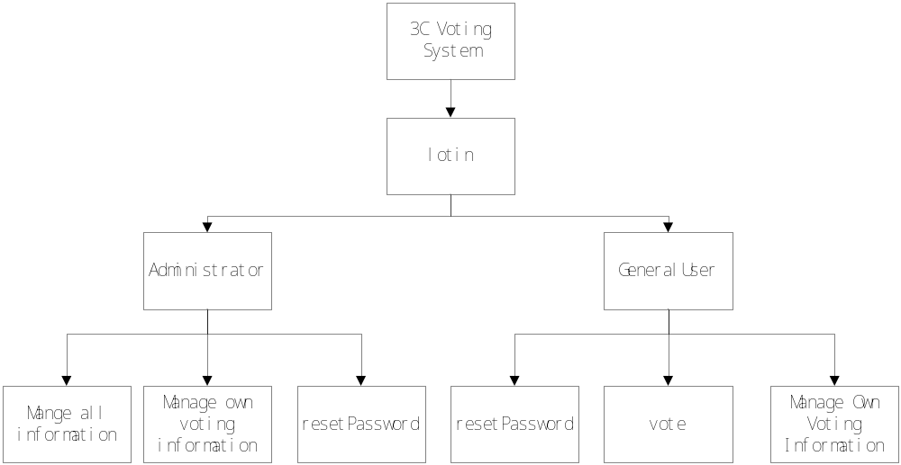

2,System Use case:
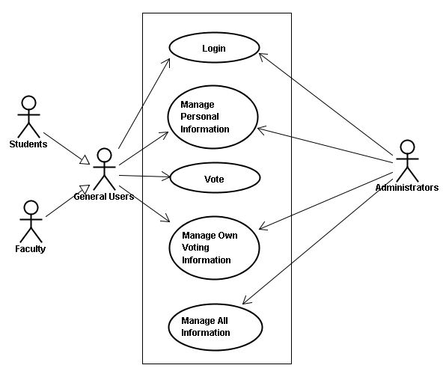

3,System Class Diagram:这个要整合下吧？

4,System E-R Diagram这个也要整合下吧？

Part2: General User

1，Features for general users:
Professional for voting, beautiful webs for users;
Single choice and multiple choice vote for text and images;
key words to search for interesting topic;
Vote and comment, involve more information;
Set privilege to select voters;
Set the times voters can vote for the same topic, only once;
Set begin and end time;
Show vote result clearly using table or chart;
Always get top 10 newly or popular ranking;
Click on any topic, can see details about this vote;
2 Sequence Diagram:这个就是你画的那个，具麻烦，没有时间，暂时先放着哈。

3，Class Diagram:
generalUser can launch a new vote, vote for the topics launched by others. Vote topics can be edited and deleted. Every vote topic has its vote topic items.

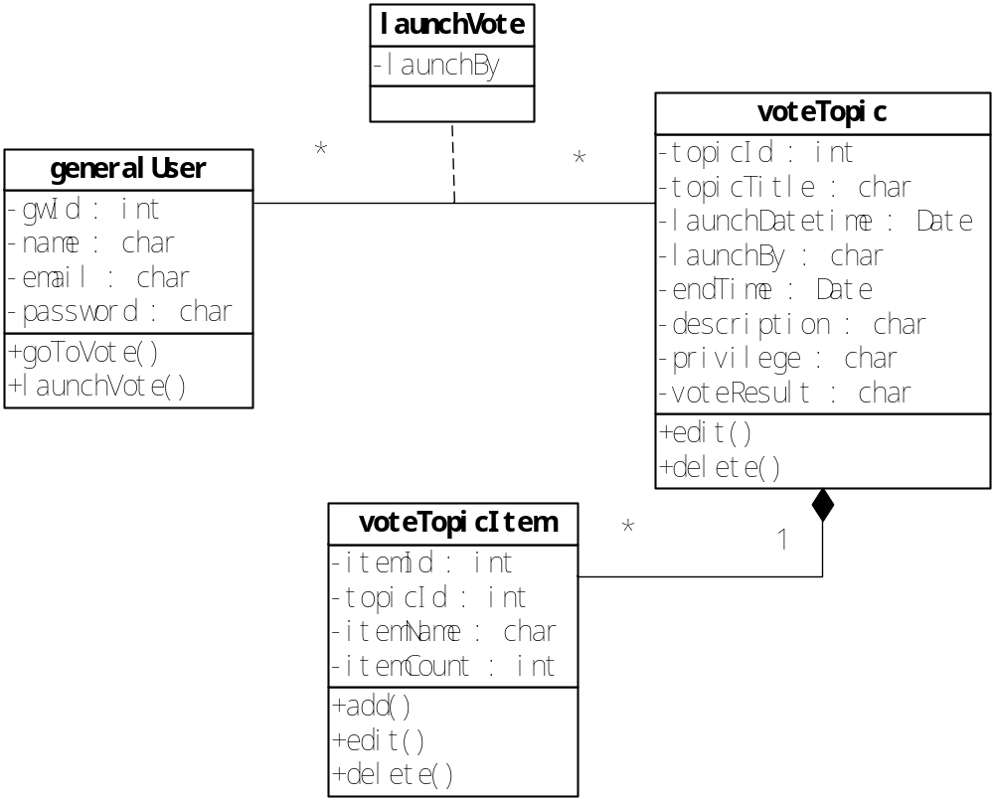

4，Function Module:
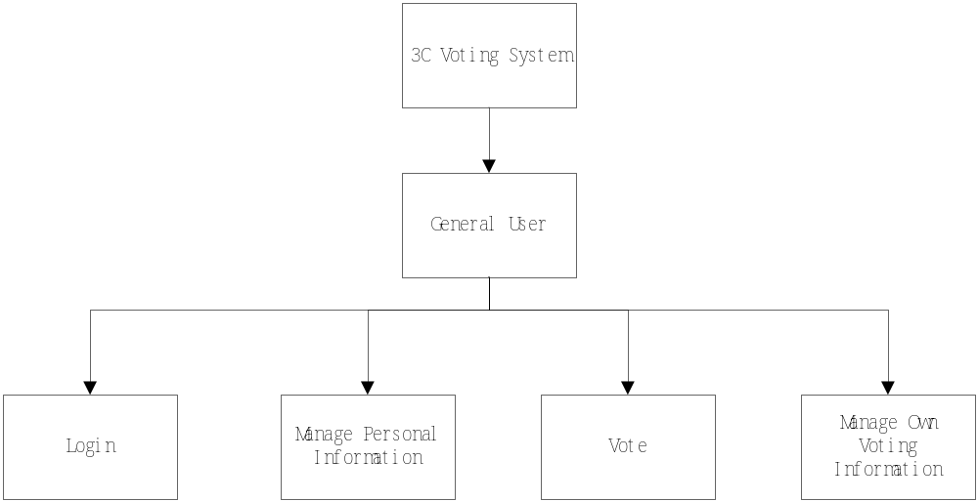
5，Use case:
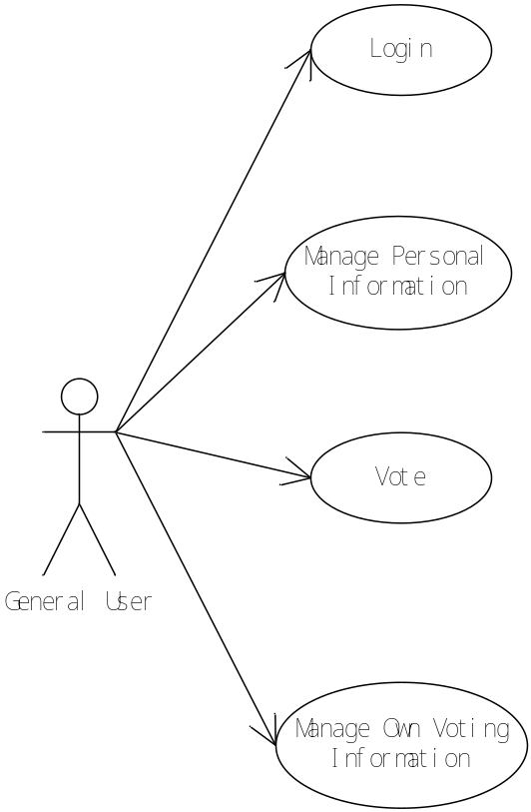

Part 3 business flow and state diagram:
1,login
General users can login by their gwid and password. If they forgot their password, they can request to find their password back.
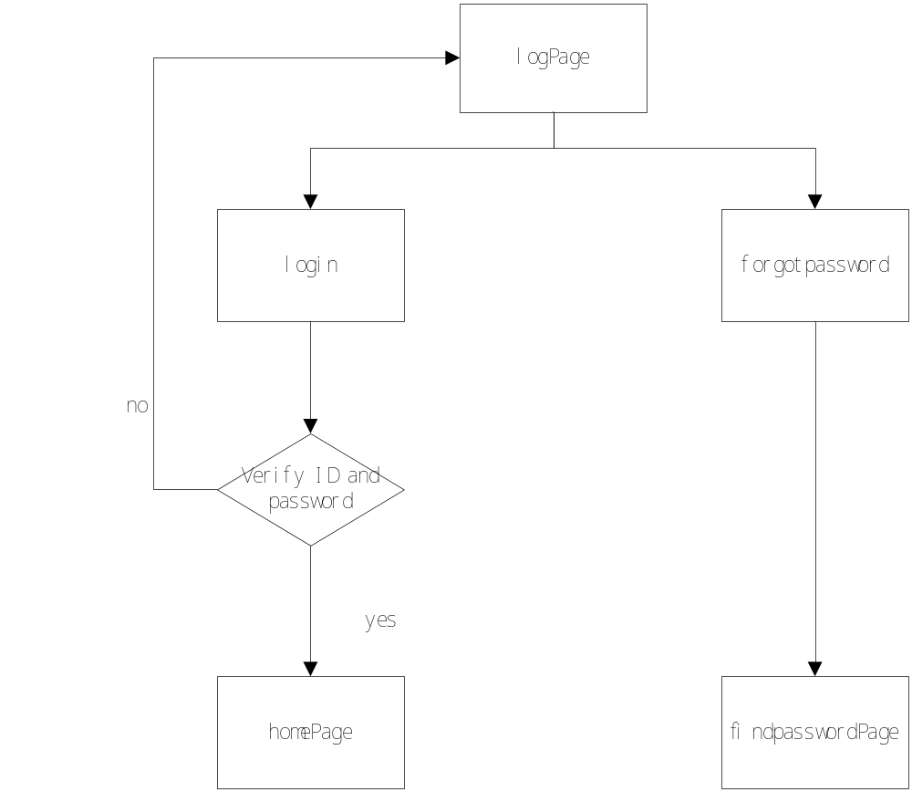
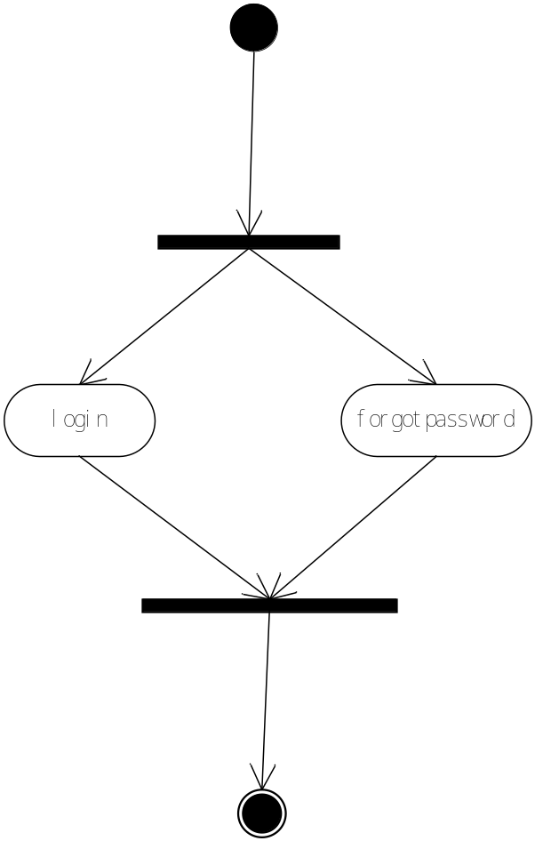
2，find password:
General users submit their gwid and email address, then they can receive their password in their email.
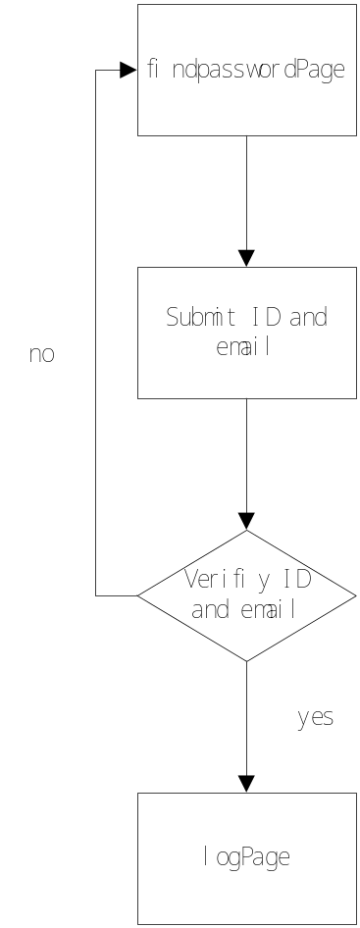


3,view vote:
General users successfully login to the system.
They can view top10 vote topics recommended by the administrator, top10 vote topics voted by the largest number of people, top10 vote topics newest launched. They can select a topic to vote by click on the title of the vote topic.
They can input key words in the search engine, and get the vote topics related to the key words. Then they can select topic.
They can click on the their name link and go to their personal page.
Then can click the logout link to quit the system and back to the login page.
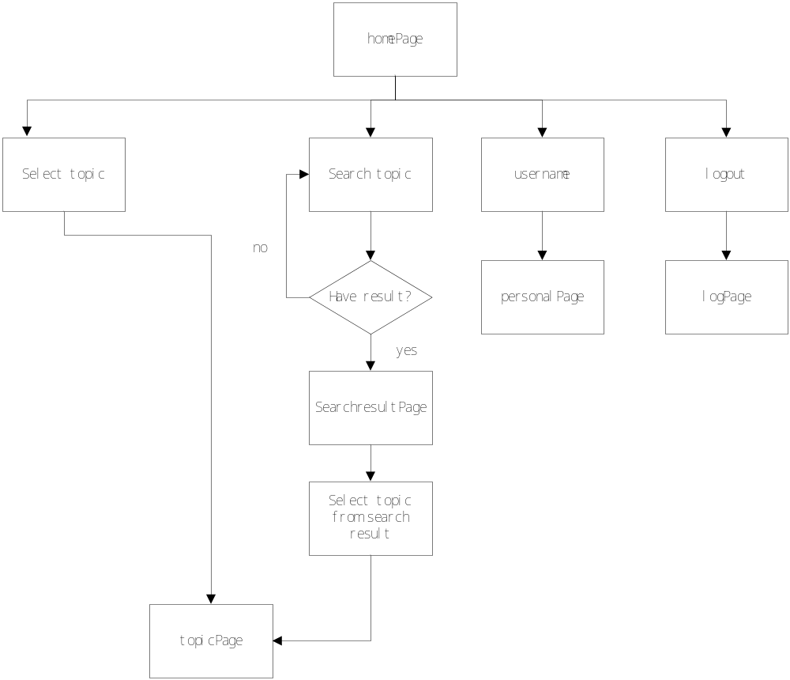

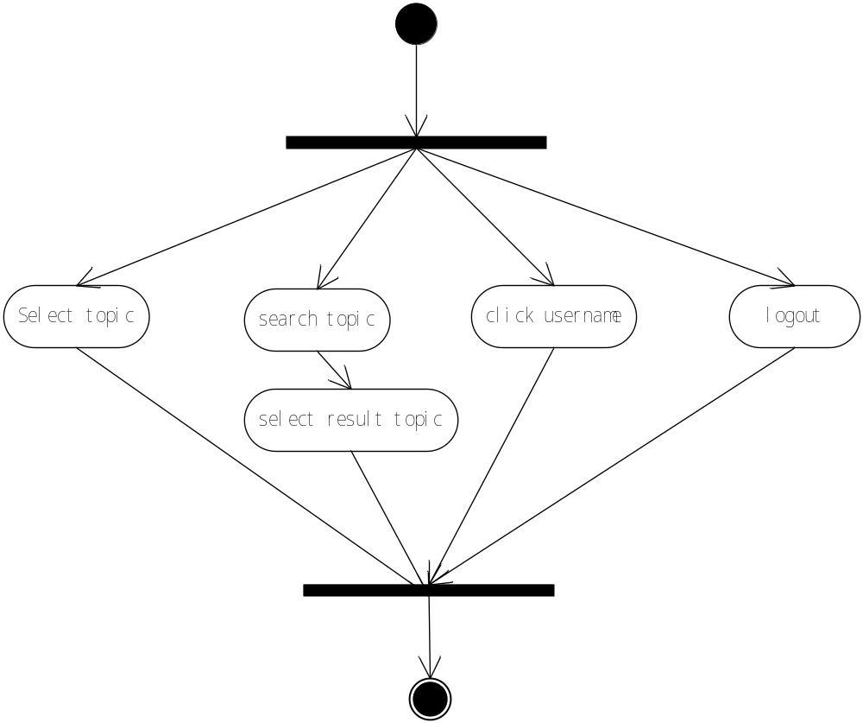

4, manage own voting information:
In general users' personal page. The default page is my vote.
They can see the vote topics they have voted before, every page will list ten topics ordered by date. Users can delete these vote topics from the list.
They can also see the vote topics they launched. They can delete the vote topics. They can edit the topics to make changes about the topics or cancel the vote topic.
They can click the go to vote link and will back to homepage.
They can click the reset password link to change their password.
They can click the message link to view messages received.
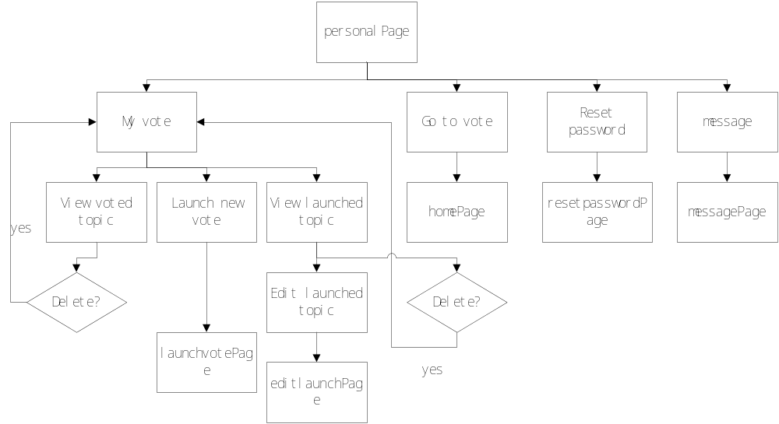

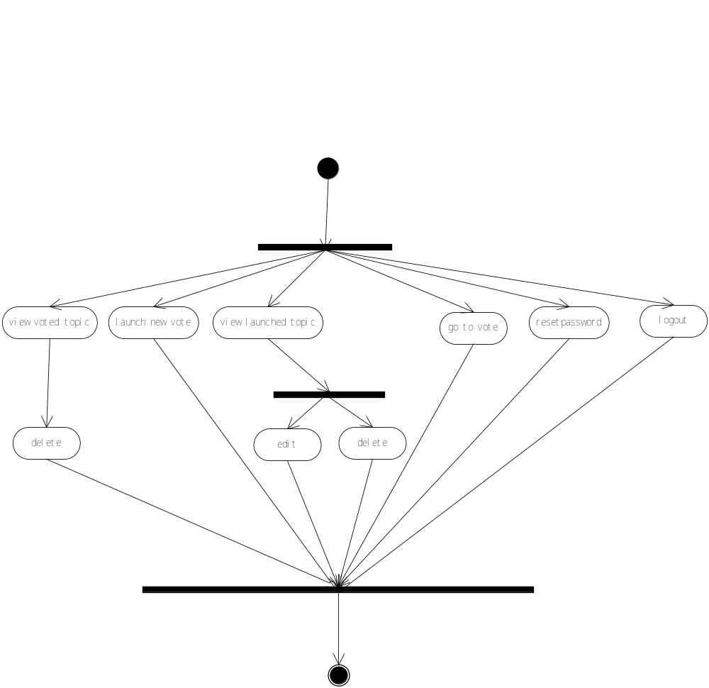

5, launch a new vote:
General users can launch a new vote, input the information needed, then submit.
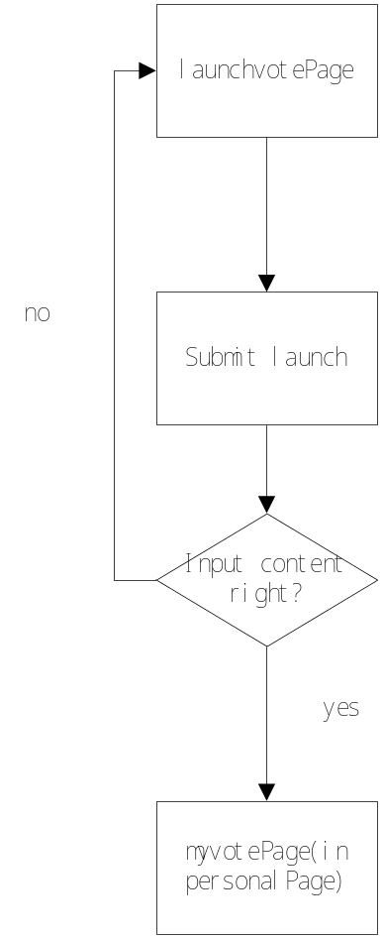


6, edit launched vote:
General users can change the vote information or even cancel the vote topic that haven't ended.
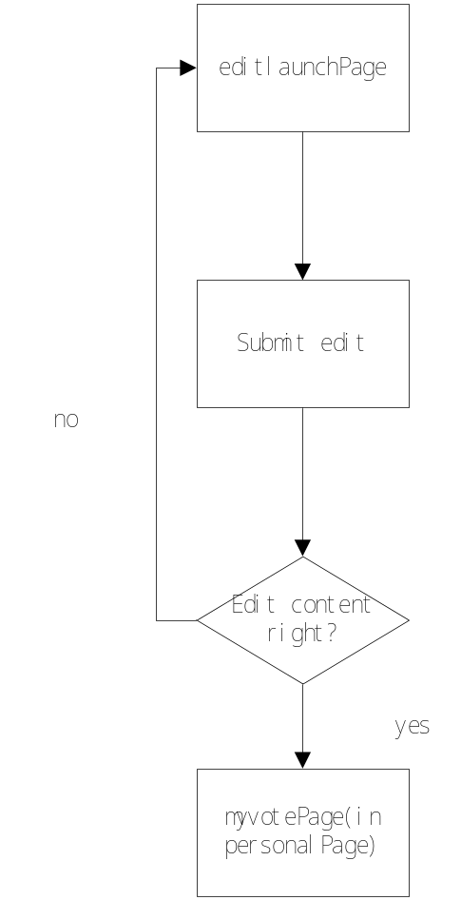


7,go to vote:
General users click the go to vote link, if the vote hasn't ended, they will go to the vote page to vote for the topic. If the vote has ended, the system will notice the user, then the user will stay in the current page.
If users think this topic is not appropriate, they can report the topic by sending a message to the administrator.
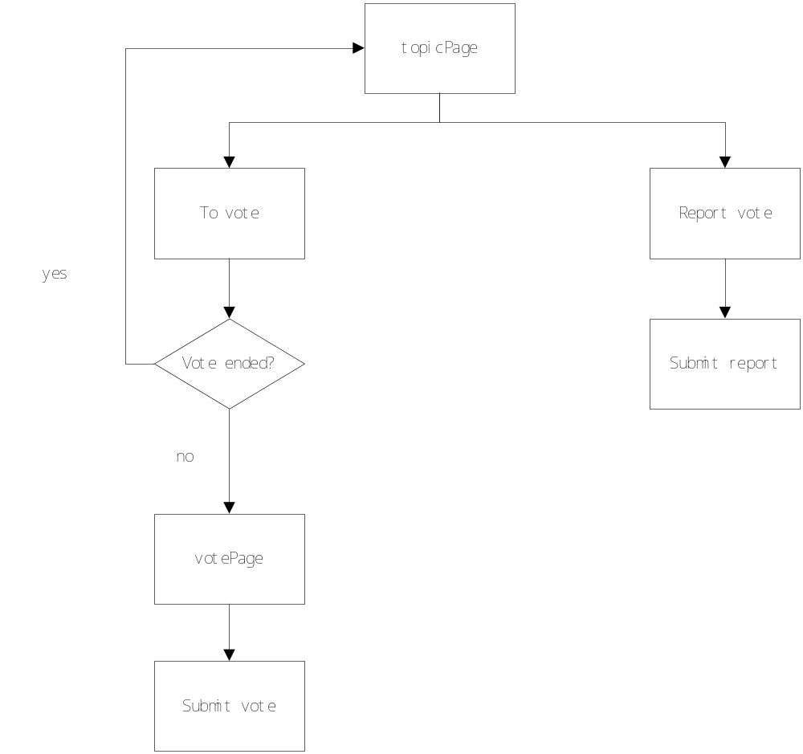
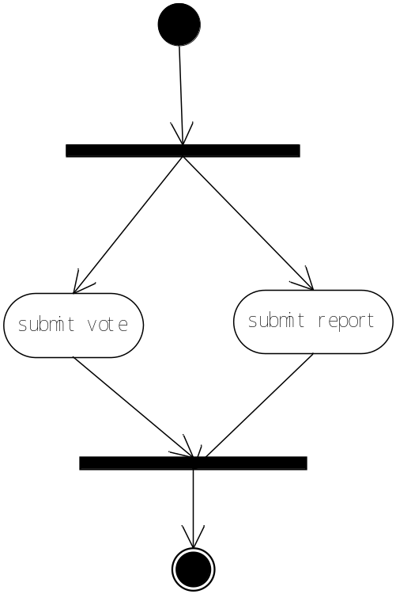
8, reset password:
General users input their current password and new password to change their password.
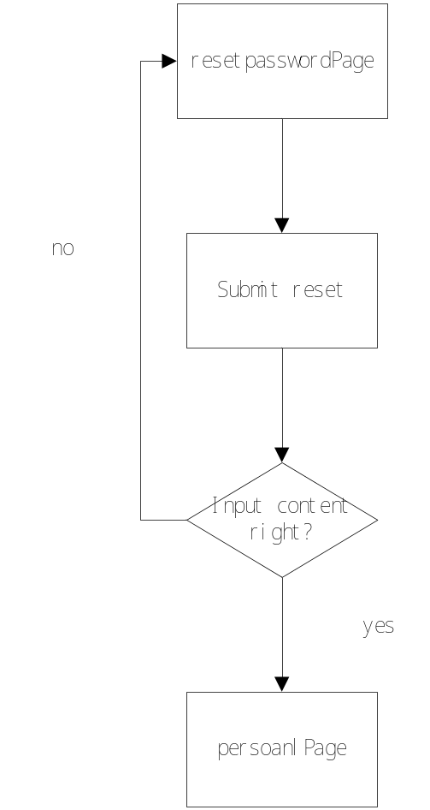


9, view message:
After clicking on the message link, the general users can view all the messages they received, each page will list 10 messages.
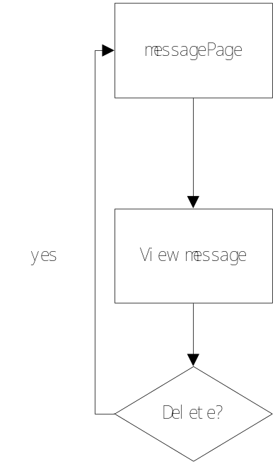
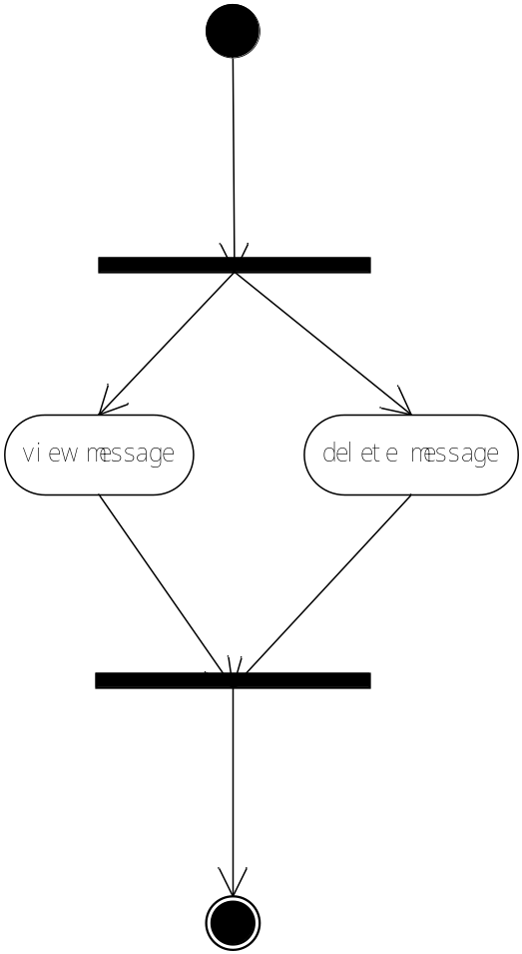

Part4:database design
1，E-R图：
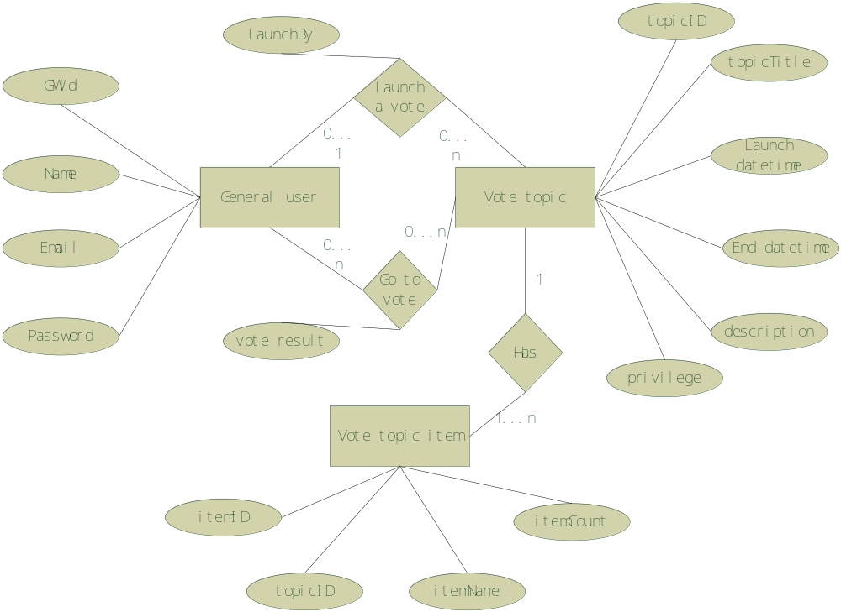
2，Using MySQL,, Database tables：
We currently have three tables to store the general Users' personal information and the vote information.

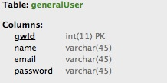

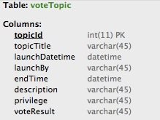
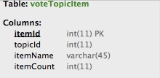

Part5 web design
1,logPage
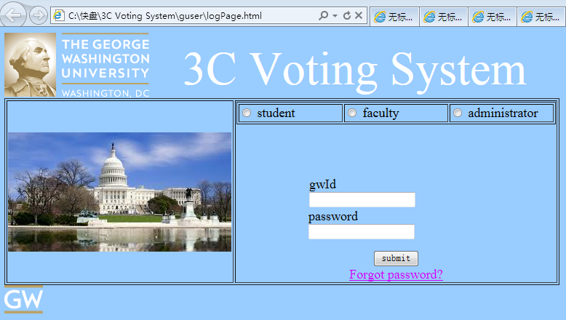

2,findpasswordPage
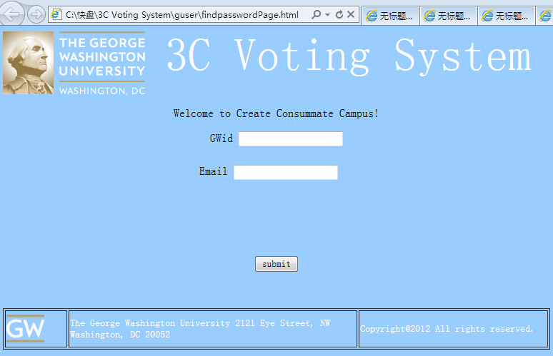
3,homePage
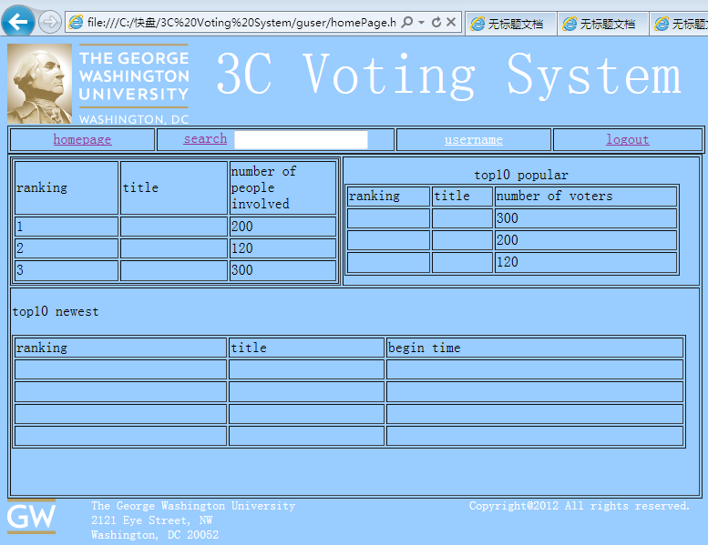

4, searchresultPage
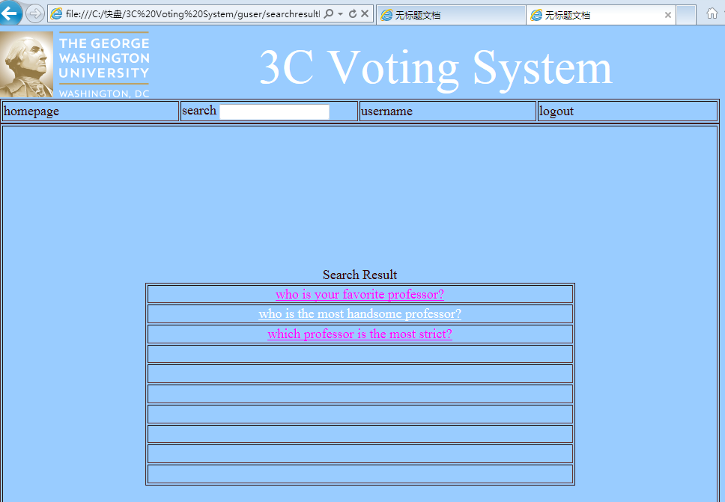
5,topicPage
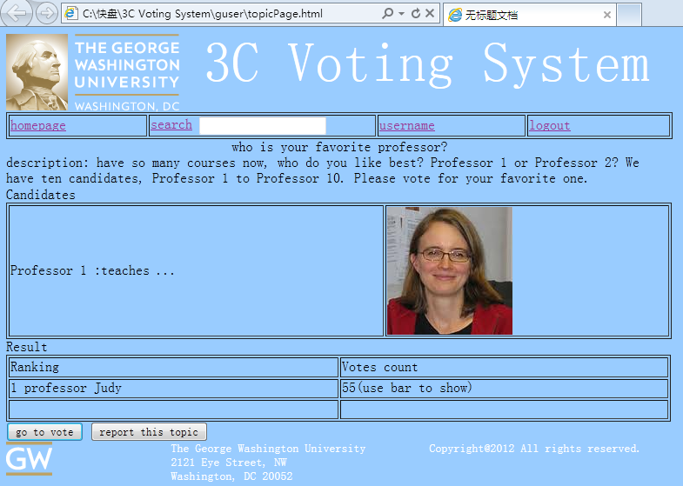

6, votePage
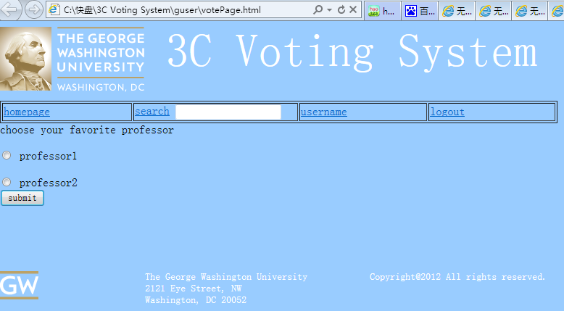
7,personalPage
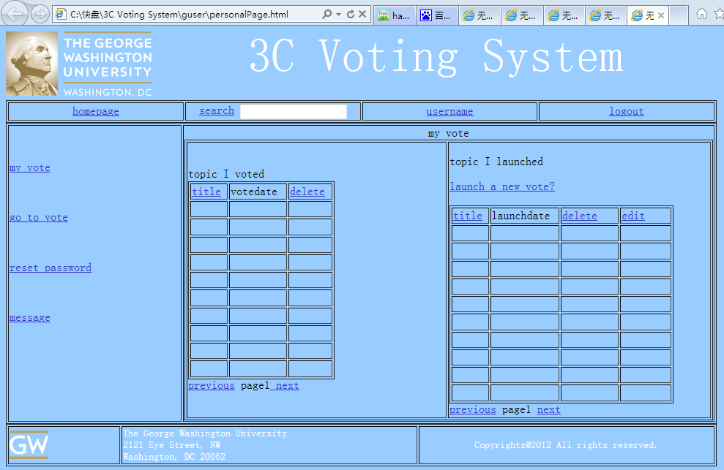

8,launchvotePage
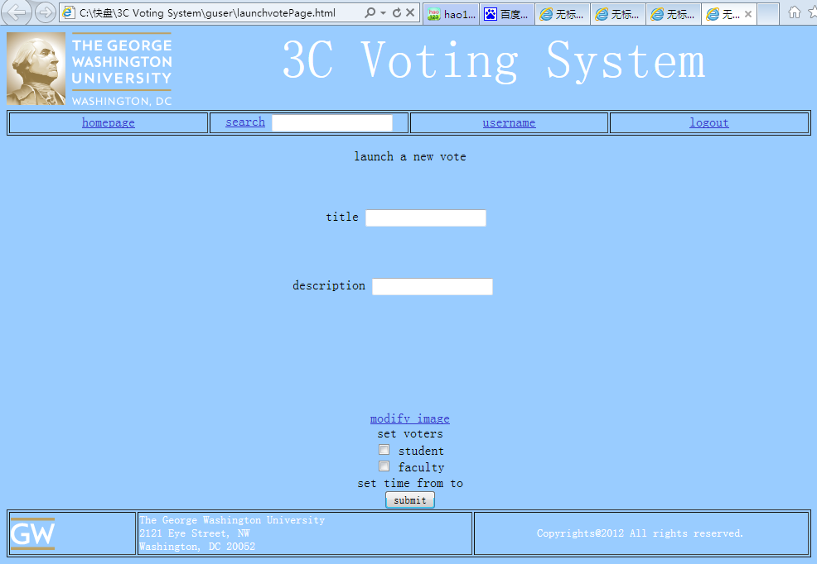
9，editlaunchPage
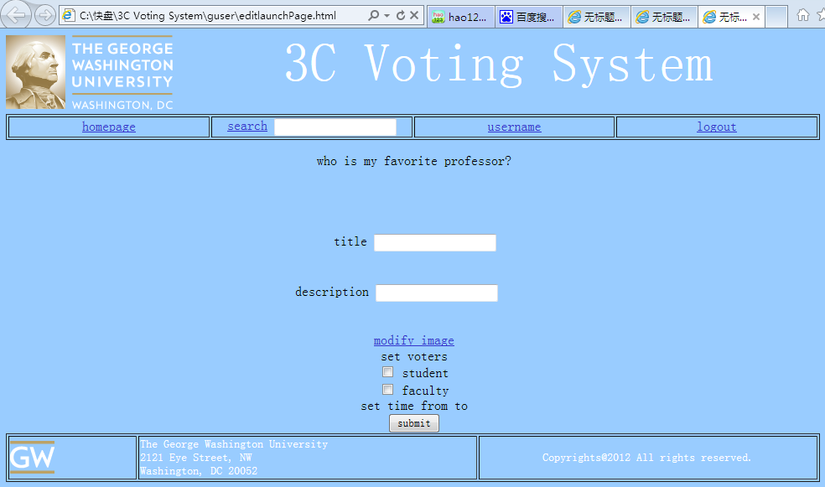

10,resetpasswordPage
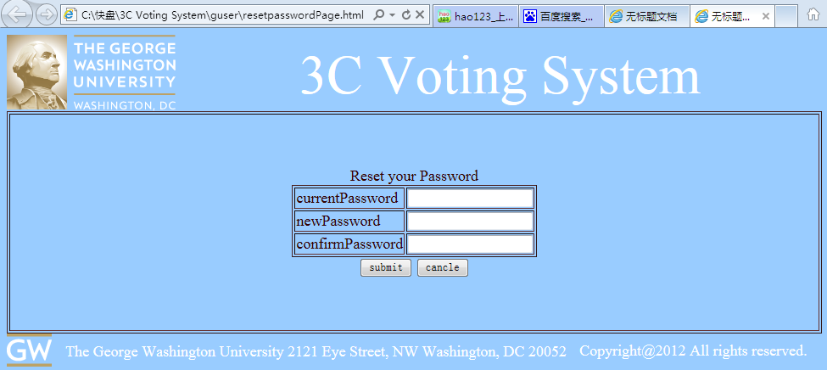
11,messagePage
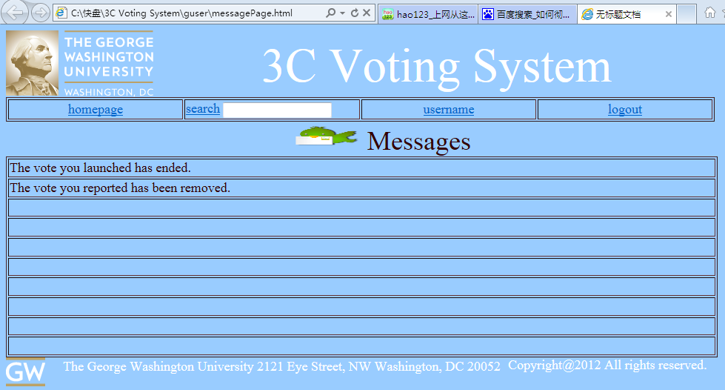

Part6,detail design:
1, develop catalog( web design catalog, coding catalog,database catalog)
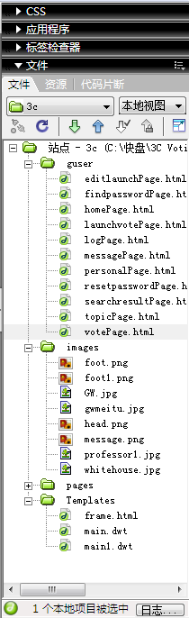

SSH framework:
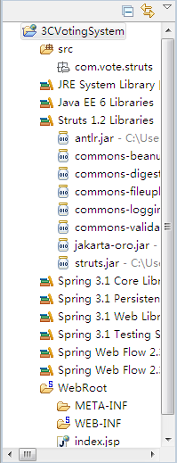

2,web code
3,java code
4,connect to database code
这几个估计没时间弄了。先放着吧？

